1. **R**ecap:
   1. **UserDetails** is blueprint/schema/contract used to represent the actual users inside the spring security.
2. **Agenda**:
   1. UserDetailsService.
3. **UserDetailsService**:
   1. Containing only one abstract method.
   2. 
4. 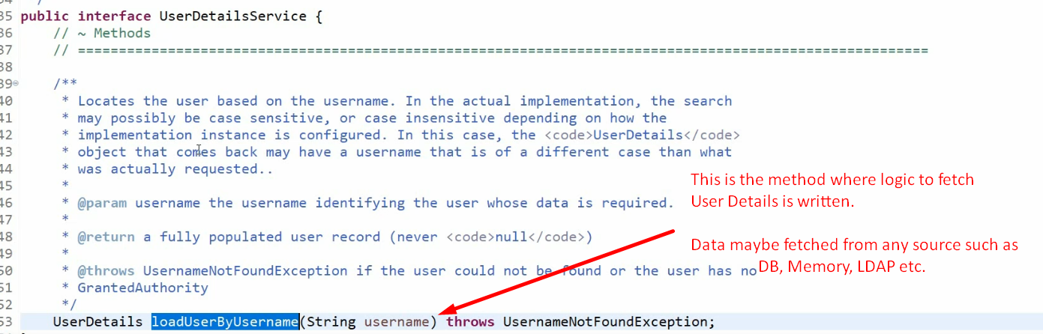
5. 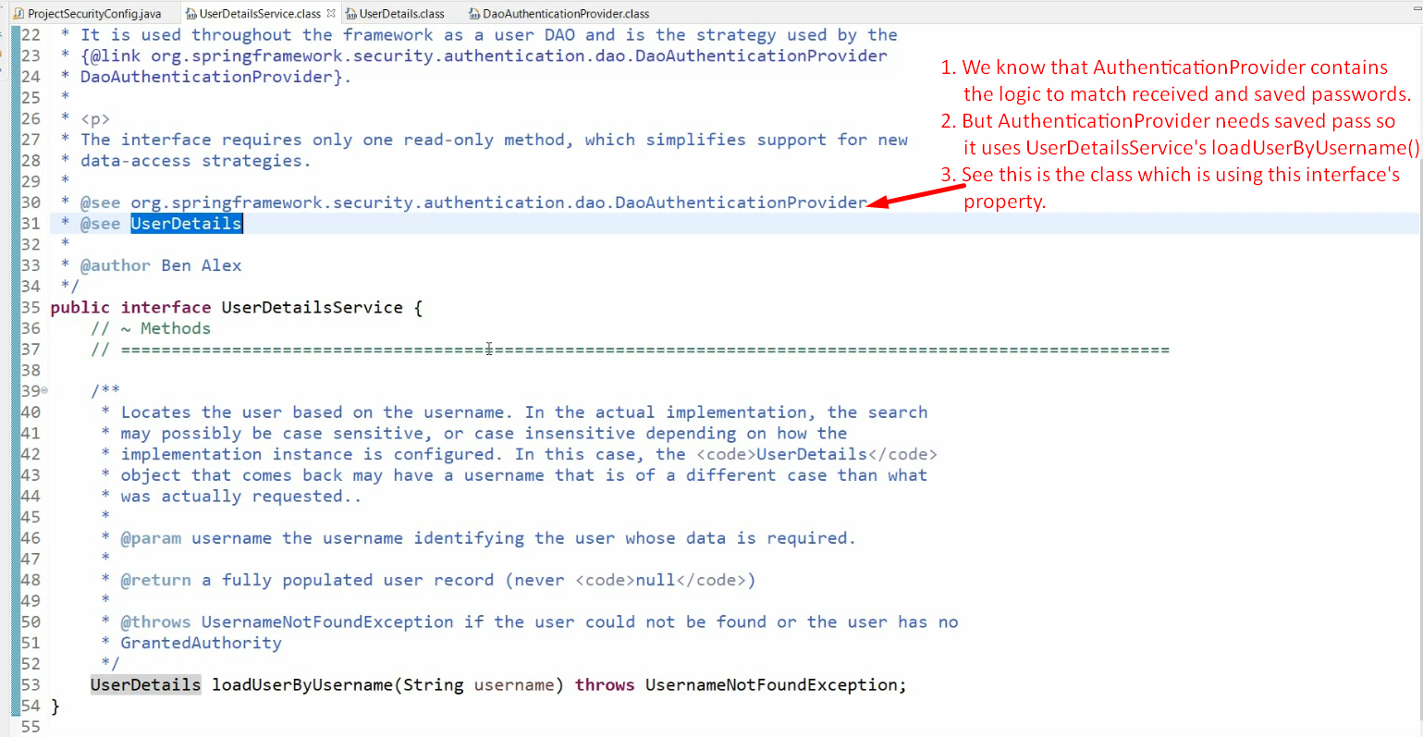
6. 